**PREDICTING THE PRICE OF A STOCK OF AN ORGANIZATION**

**Submitted by**

NAGHARJUN M 18BLC1129

AADIL ABDUL GHANI 18BLC1151

SANJAY THOLANI 18BLC1090

**J Component - Report**

**ECM2002 – Machine Learning Algorithms**

**BACHELOR OF TECHNOLOGY**

in

**ELECTRONICS AND COMPUTER ENGINEERING**



**June 2020**

**TABLE OF CONTENTS**

|  |  |  |  |
| --- | --- | --- | --- |
| **SL. NO.** |  | **TITLE** | **PAGE NO.** |
|  |  |  |  |
|  |  |
|  |  |
| 1 |  | ABSTRACT  INTRODUCTION | 3  4 |
|  |  |  |  |
|  | 1.1 | OBJECTIVES | 4 |
|  | 1.2 | BENEFITS | 4 |
|  |
|  |  |  |  |
| 2 |  | LSTM MODEL DESIGN | 5 |
|  | 2.1 | BLOCK DIAGRAM | 5-6 |
|  | 2.2  2.3  2.4  2.5 | WHAT ARE STOCKS  WHAT IS MACHINE LEARNING  RECURRENT NEURAL NETWORKS  LONG SHORT TERM MEMORY | 7  7  7  8 |
|  |  |  |  |
| 3 | 3.1  3.1.2 | PREDICTION AND ANALYSIS  PREDICTION OF 3 ORGANIZATIONS  LSTM MODEL USING KERAS | 9  9  9-10 |
|  | 3.1.3  3.1.4  3.1.5  3.2 | TESLA STOCK PRICE PREDICTION AND ACCURACY  APPLE STOCK PRICE PREDICTION AND ACCURACY  XILINX STOCK PRICE PREDICTION AND ACCURACY  APPLICATIONS | 11  12  13  14 |
| 4 |  | CONCLUSION AND FUTURE WORK | 15 |
|  | 4.1 | CONCLUSION | 15 |
|  | 4.2 | FUTURE WORK | 15 |

5 REFERENCES 16

**CHAPTER 1**

**ABSTRACT**

The main aim of this project is to successfully select and perform a machine learning algorithm or model to accurately predict the future price value of a stock of a company or organization. We are using Google Colab to perform the suitable machine learning model.

**INTRODUCTION**

**1.1 OBJECTIVES**

* Designing Stock Price Prediction Algorithm.
* Detect the future prices of stocks of different organizations.

**1.2 BENEFITS**

LSTMs are an improved version of recurrent neural networks (RNNs). RNNs are analogous to human learning. When humans think, we don’t start our thinking from scratch each second. For example, in the sentence “Bob plays basketball”, we know that Bob is the person who plays basketball because we retain information about past words while reading sentences. Similarly, RNNs are networks with loops in them, which allow them to use past information before arriving at a final output. However, RNNs can only connect recent previous information and cannot connect information as the time gap grows. This is where LSTMs come into play; LSTMs are a type of RNN that remember information over long periods of time, making them better suited for predicting stock prices. Using the features of the LSTM RNN we are designing the proposed project.

**CHAPTER 2**

**LSTM MODEL - DESIGN**

**2.1 BLOCK DIAGRAM**

The main features of the basic block diagram below are

* LSTM Model
* Training Data
* Testing Data

**Figure 1. LSTM MODEL**

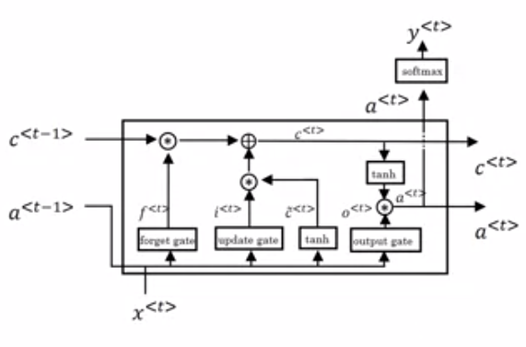

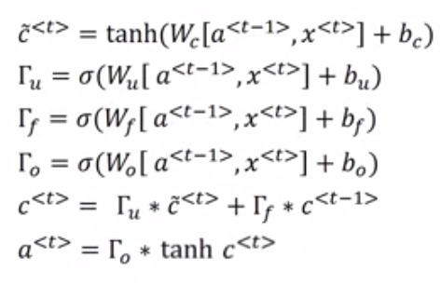

**Figure 2. MODEL DIAGRAM AND EQUATIONS**

**2.2 WHAT ARE STOCKS**

Stocks are securities that represent an ownership share in a company. For companies, issuing stock is a way to raise money to grow and invest in their business. For investors, stocks are a way to grow their money and outpace inflation over time. When you own stock in a company, you are called a shareholder because you share in the company’s profits.

**2.3 WHAT IS MACHINE LEARNING**

**Machine learning** (**ML**) is the scientific study of algorithms and statistical models that computer systems use to perform a specific task without using explicit instructions, relying on patterns and inference instead. It is seen as a subset of artificial intelligence.

TYPES OF ML MODELS:

Supervised Learning

Unsupervised Learning

Reinforcement Learning

**2.4 RECURRENT NEURAM NETWORKS**

A recurrent neural network (RNN) is a class of artificial neural networks where connections between nodes form a directed graph along a temporal sequence. This allows it to exhibit temporal dynamic behavior. Derived from feedforward neural networks, RNNs can use their internal state (memory) to process variable length sequences of inputs. This makes them applicable to tasks such as unsegmented, connected handwriting recognition or speech recognition. The term “recurrent neural network” is used indiscriminately to refer to two broad classes of networks with a similar general structure, where one is finite impulse and the other is infinite impulse. Both classes of networks exhibit temporal dynamic behavior. A finite impulse recurrent network is a directed acyclic graph that can be unrolled and replaced with a strictly feedforward neural network, while an infinite impulse recurrent network is a directed cyclic graph that cannot be unrolled.

**2.5 LONG SHORT TERM MEMORY**

Long Short Term Memory networks – usually just called “LSTMs” – are a special kind of RNN, capable of learning long-term dependencies. They were introduced by [Hochreiter & Schmidhuber (1997)](http://www.bioinf.jku.at/publications/older/2604.pdf), and were refined and popularized by many people in following work.[1](https://colah.github.io/posts/2015-08-Understanding-LSTMs/) They work tremendously well on a large variety of problems, and are now widely used.

LSTMs are explicitly designed to avoid the long-term dependency problem. Remembering information for long periods of time is practically their default behavior, not something they struggle to learn!

All recurrent neural networks have the form of a chain of repeating modules of neural network. In standard RNNs, this repeating module will have a very simple structure, such as a single tanh layer.

**CHAPTER 3**

**PREDICTION AND ANALYSIS**

**3.1 PREDICTION OF 3 ORGANIZATIONS**

* + Tesla
  + Apple
  + Xilinx

**3.1.2 LSTM MODEL USING KERAS**

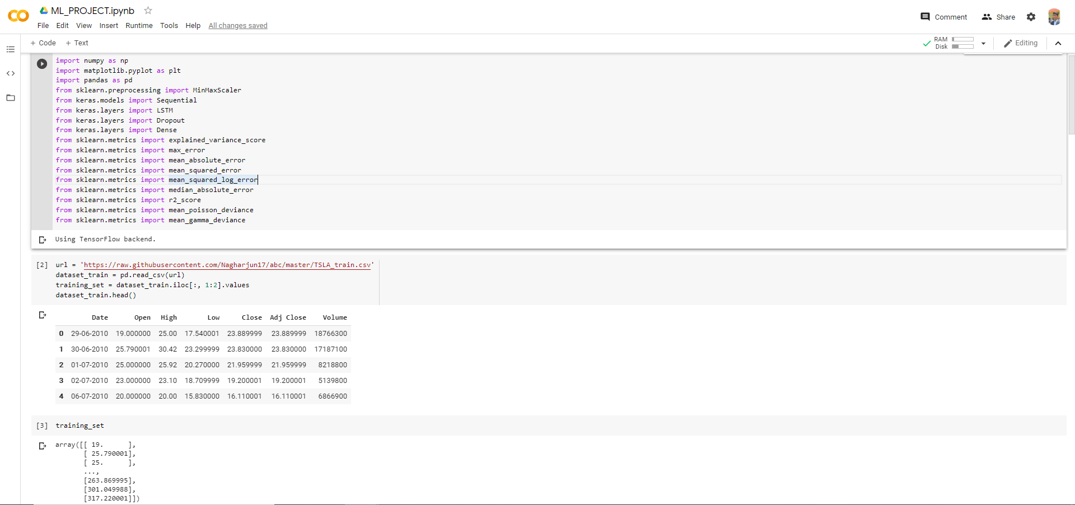

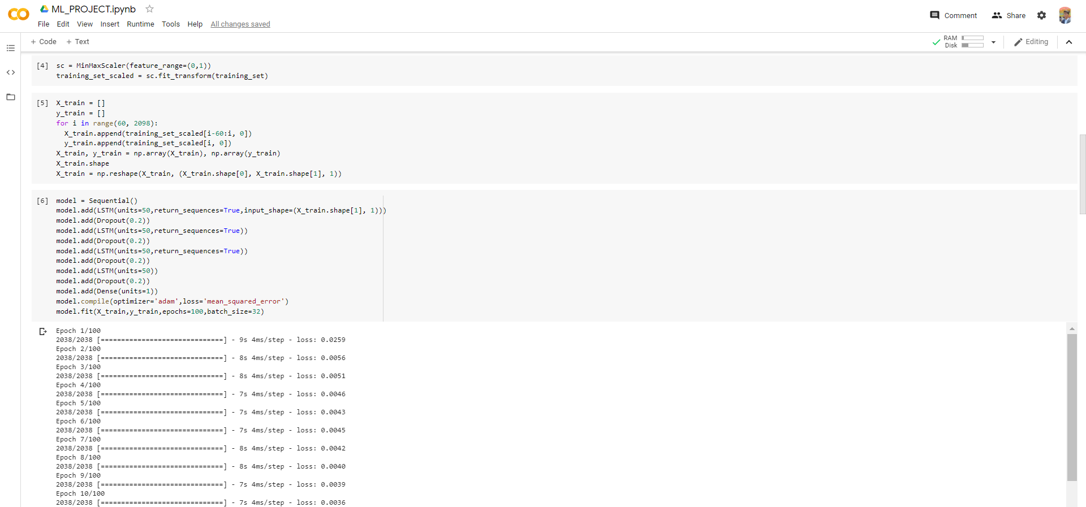

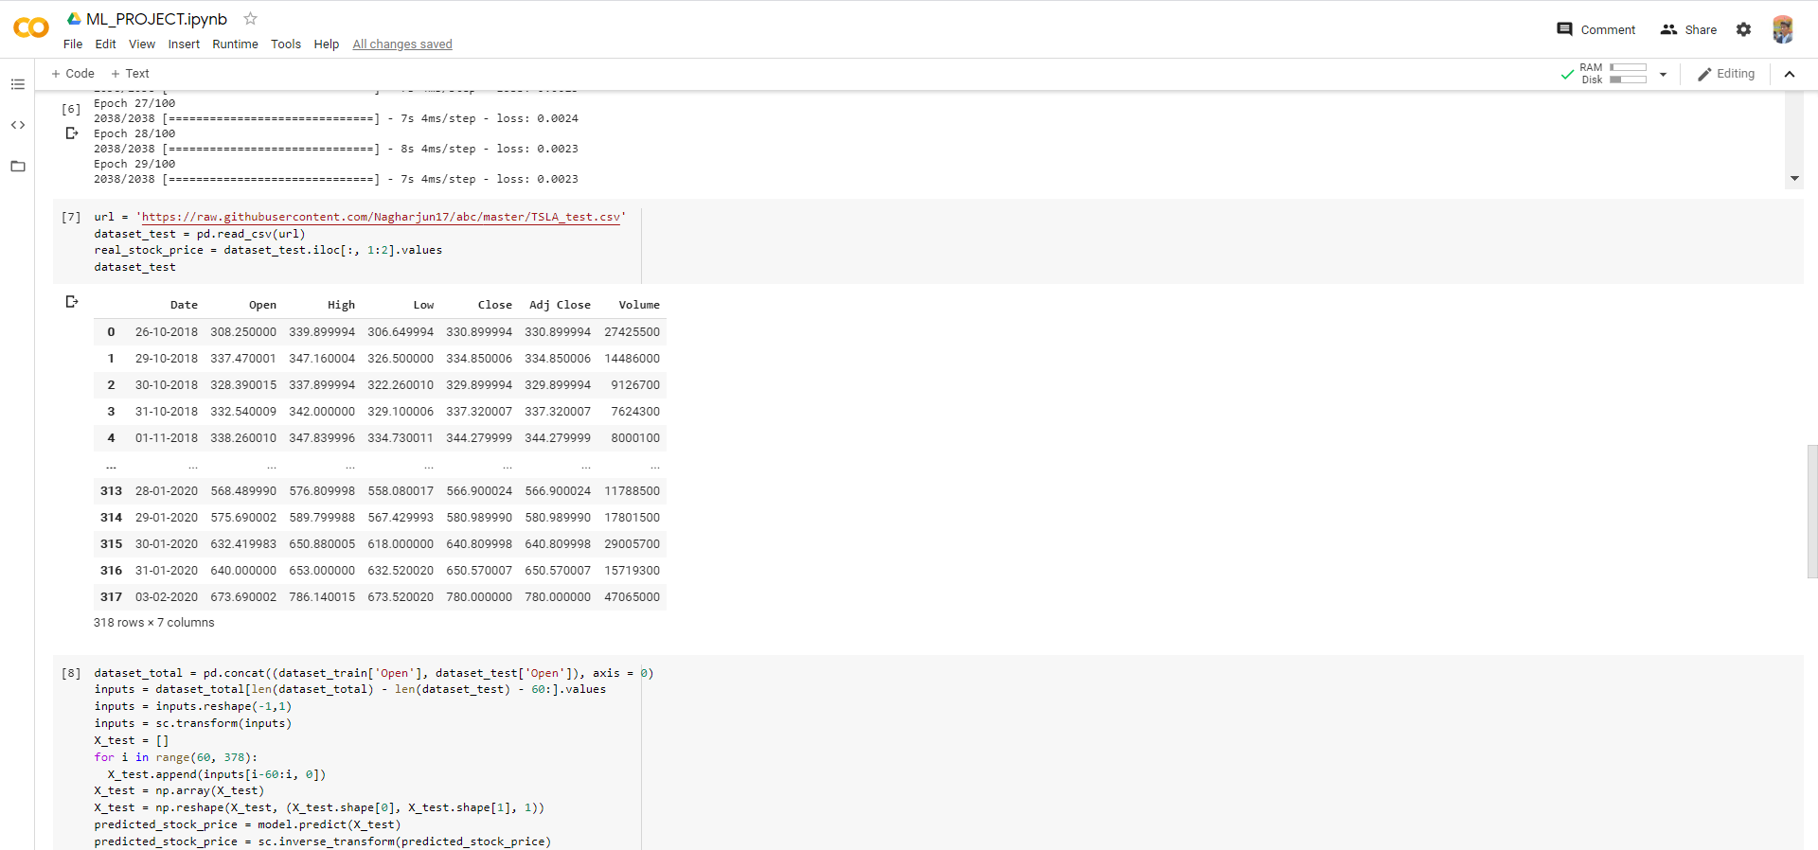

**3.1.3 TESLA STOCK PRICE PREDICTION AND ACCURACY**

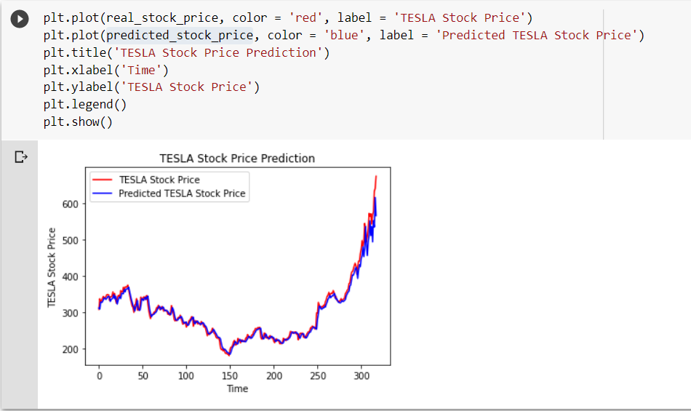

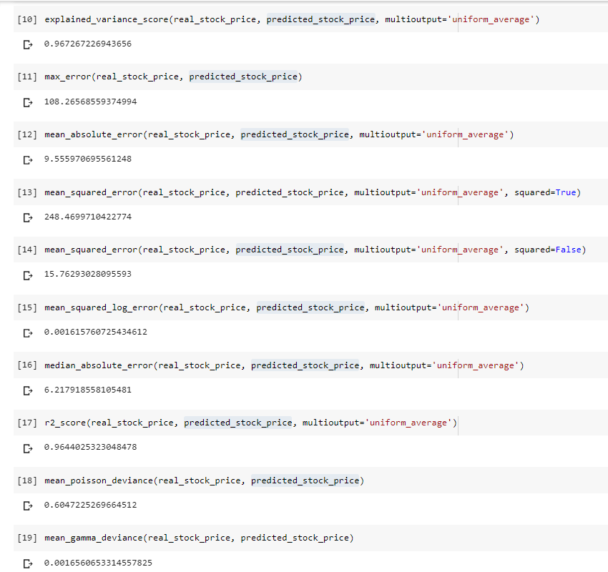

**3.1.3 APPLE STOCK PRICE PREDICTION AND ACCURACY**

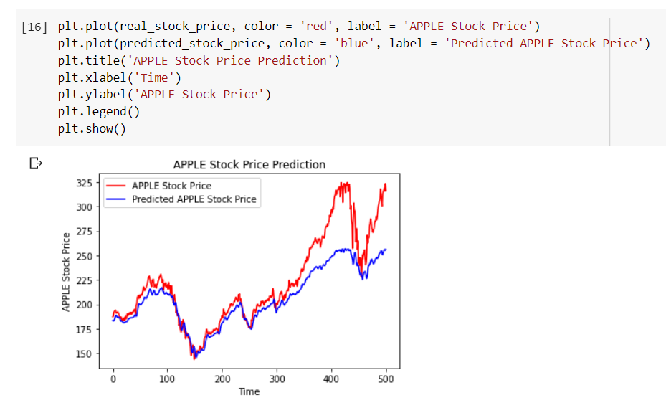

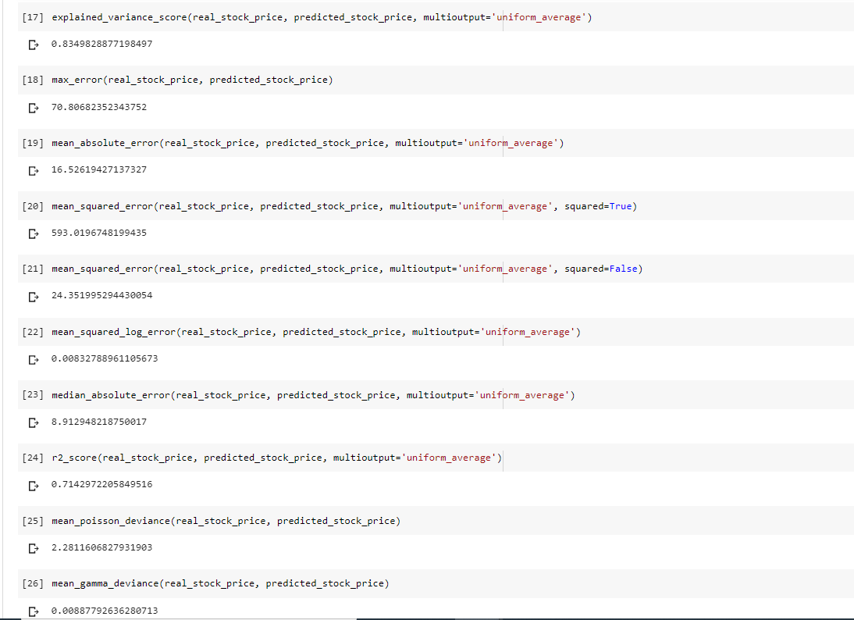

**3.1.4 XILINX STOCK PRICE PREDICTION AND ACCURACY**

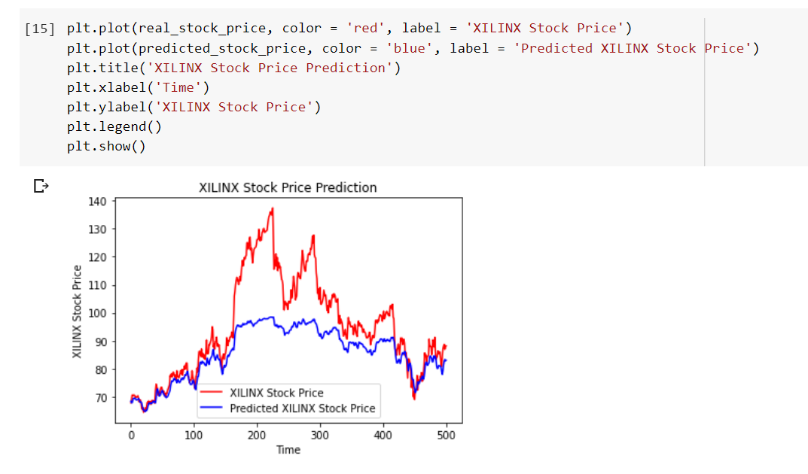

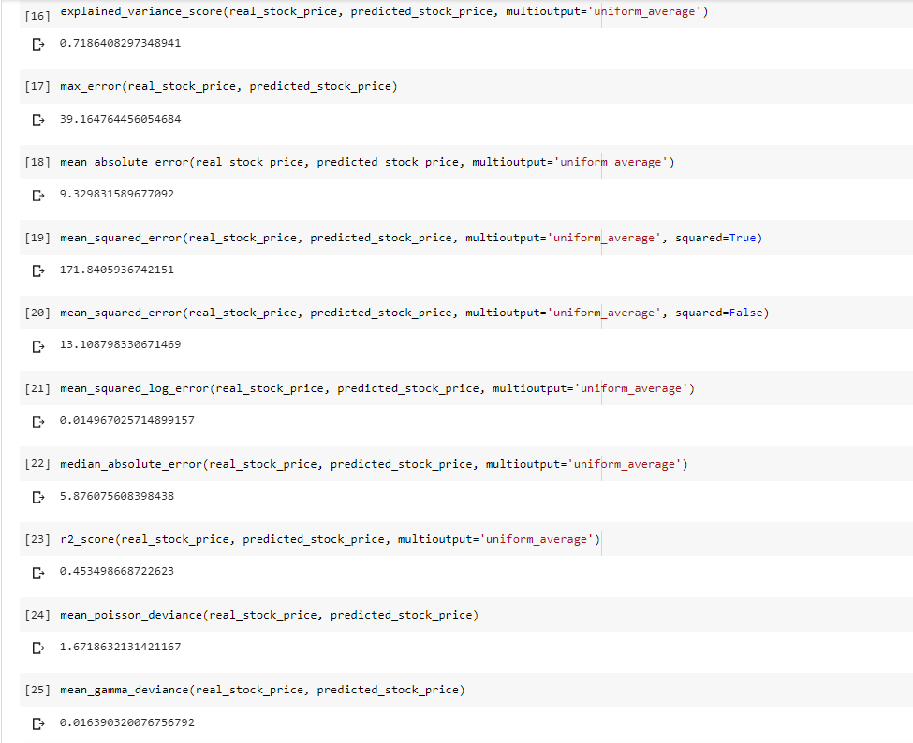

**3.2 APPLICATIONS**

* It can be used to predict any stock price of any organization.
* It can accurately measure the stock price.
* It can accurately measure with less units.

**CHAPTER 4**

**CONCLUSION AND FUTURE WORK**

**4.1 CONCLUSION**

* The Stock Price Predictor was built and implemented.
* The system is targeted for people with who invests in stocks.
* The prototype developed can work in any other applications also.
* The final results are good.

**4.2 FUTURE WORK**

* The accuracy can be increased.
* Can increase the training set contents.

**CHAPTER 5**

**REFERENCES**

[1] “Stock Market Analysis: A Review and Taxonomy of Prediction Techniques”, Dev Shah, Haruna Isah * and Farhana Zulkernine School of Computing, Queen’s University, Kingston, ON K7L 2N8, Canada; dshah@cs.queensu.ca (D.S.); farhana@cs.queensu.ca (F.Z.)

[2] Osman Hegazy , Omar S. Soliman and Mustafa Abdul Salam “A Machine Learning Model for Stock Market Prediction” in International Journal of Computer Science and Telecommunications [Volume 4, Issue 12, December 2013]

# [3] K. Hiba Sadia, Aditya Sharma, Adarrsh Paul, SarmisthaPadhi, Saurav Sanyal “Stock Market Prediction Using Machine Learning Algorithms “in International Journal of Engineering and Advanced Technology (IJEAT) ISSN: 2249 – 8958, Volume-8 Issue-4, April 2019

[4] Ashraf S. Hussein , Ibrahim M. Hamed , and Mohamed F. Tolba“An Efficient System for Stock Market Prediction”